##### **DATABASE ITSS**

Mô hình khái niệm ERD

<https://drive.google.com/file/d/1-AnHpCnRsu_Da2eqp1BsW1NLSCPnogOP/view?usp=sharing>

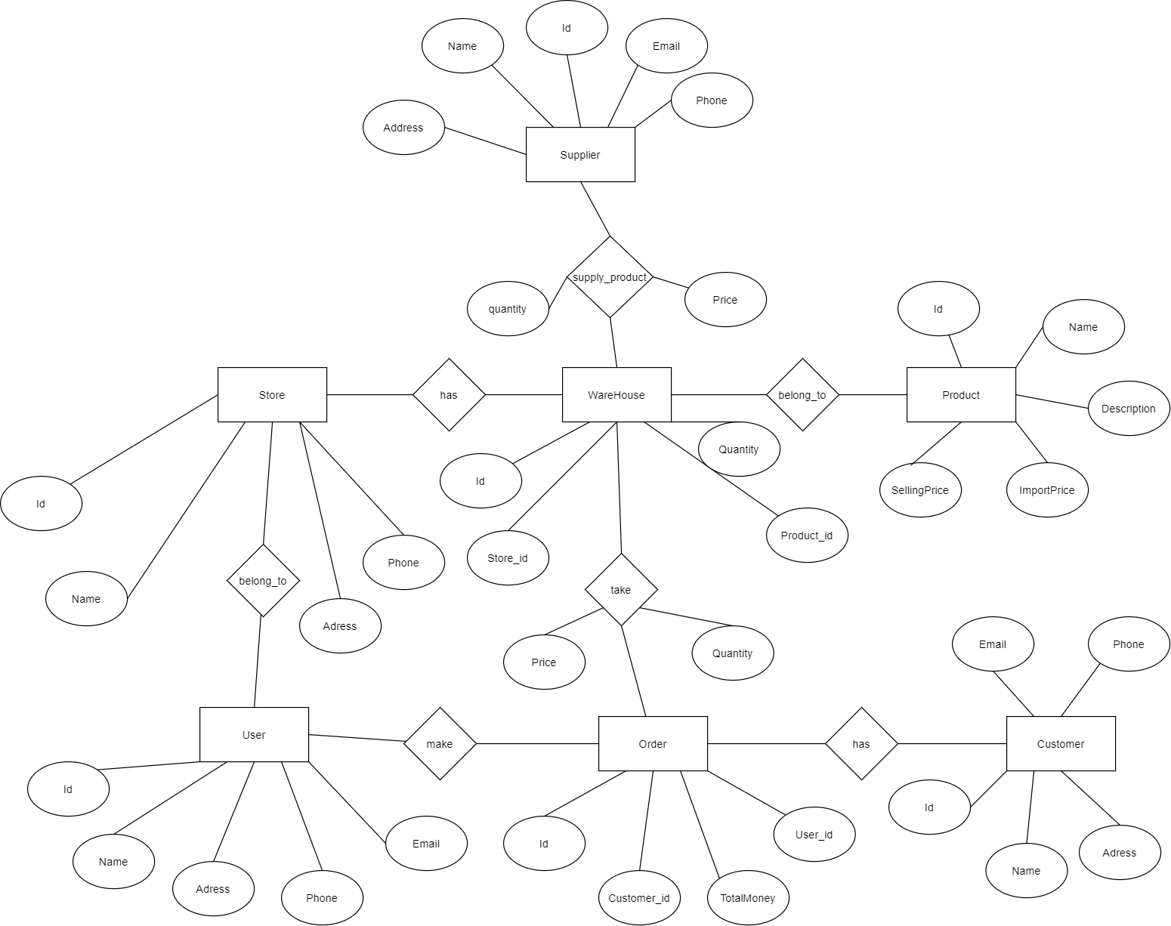

##### **a)** **Mô hình dữ liệu logic (Logical data model)**

<https://drive.google.com/file/d/1ct0BqMNhgldblGq3ZEytm4cJDqxoNPLa/view>

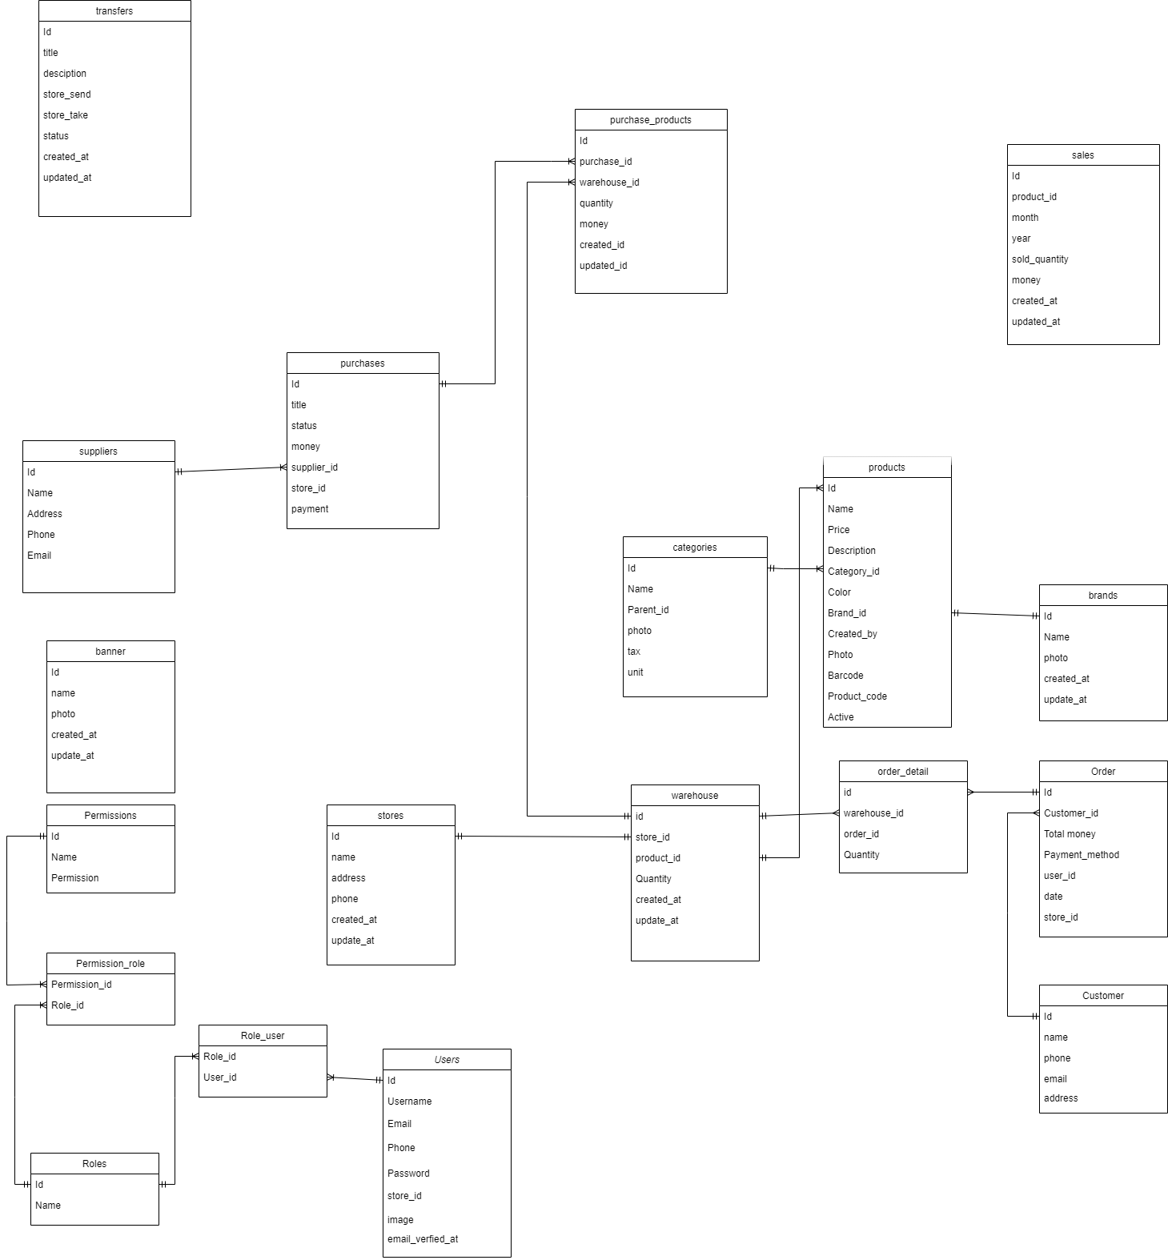

##### **b)** **Mô hình dữ liệu vật lý (Physical data model)**

* **Banners**

| **#** | **PK** | **FK** | **Column Name** | **Data type** | **Mandatory** | **Description** |
| --- | --- | --- | --- | --- | --- | --- |
| **1.** | **x** | **x** | **id** | **BIGINT** | **Yes** | **ID banner** |
| **2.** |  |  | **name** | **VARCHAR(255)** | **Yes** | **title banner** |
| **3.** |  |  | **photo** | **VARCHAR(255)** | **Yes** | **image banner** |
| **4.** |  |  | **created_at** | **TIMESTAMP** | **Yes** | **create time** |
| **5** |  |  | **updated_at** | **TIMESTAMP** | **Yes** | **update time** |

* **Brands**

| **#** | **PK** | **FK** | **Column Name** | **Data type** | **Mandatory** | **Description** |
| --- | --- | --- | --- | --- | --- | --- |
| **1.** | **x** | **x** | **id** | **BIGINT** | **Yes** | **ID brand** |
| **2.** |  |  | **name** | **VARCHAR(255)** | **Yes** | **name brand** |
| **3.** |  |  | **photo** | **VARCHAR(255)** | **Yes** | **image brand** |
| **4.** |  |  | **created_at** | **TIMESTAMP** | **Yes** | **create time** |
| **5** |  |  | **updated_at** | **TIMESTAMP** | **Yes** | **update time** |

**Products**

| **#** | **PK** | **FK** | **Column Name** | **Data type** | **Mandatory** | **Description** |
| --- | --- | --- | --- | --- | --- | --- |
| **1.** | x |  | id | BigInteger | Yes | ID, auto increment |
| **2.** |  |  | Name | Varchar(255) | Yes | Product ‘s name |
| **3.** |  |  | price | Decimal(8,2) | Yes | Price |
| **4.** |  |  | photo | Varchar (255) | Yes | Product image path |
| **5.** |  |  | description | Varchar (255) | Yes | Detail product description |
| **6.** |  |  | Color | Text | Yes | Color of product |
| **7.** |  |  | Barcode | Text | Yes | Image code |
| **8.** |  |  | Product_code | Text | Yes | Seria number |
| **9.** |  | x | Category_id | Integer | No | Category Id |
| **10.** |  | x | Created_by | BigInteger | No | User create product |
| **11.** |  | x | Brand_id | BigInteger | No | Brand Id |
| **12.** |  |  | Active | Integer | No | Public or not |

**Categories**

| **#** | **PK** | **FK** | **Column Name** | **Data type** | **Mandatory** | **Description** |
| --- | --- | --- | --- | --- | --- | --- |
| **1.** | **x** |  | **id** | **BigInteger** | **Yes** | **ID, auto increment** |
| **2.** |  |  | **name** | **Varchar(255)** | **Yes** | **Category ‘s name** |
| **3.** |  |  | **tax** | **Integer** | **No** | **Tax** |
| **4.** |  |  | **photo** | **Varchar (255)** | **Yes** | **Category image path** |
| **5.** |  |  | **description** | **Varchar (255)** | **Yes** | **Detail category description** |
| **6.** |  | **x** | **parent_id** | **Integer** | **No** | **Parent category Id** |
| **7.** |  |  | **unit** | **Varchar (55)** | **No** | **Unit** |

* **Orders**

| **#** | **PK** | **FK** | **Column Name** | **Data type** | **Mandatory** | **Description** |
| --- | --- | --- | --- | --- | --- | --- |
| **1.** | **x** |  | **id** | **BIGINT** | **Yes** | **ID orders** |
| **2.** |  | **x** | **customer_id** | **INT** | **Yes** | **id customer** |
| **3.** |  |  | **price** | **DECIMAL(8,2)** | **Yes** | **total price customer buy** |
| **4.** |  |  | **created_at** | **TIMESTAMP** | **Yes** | **create time** |
| **5** |  |  | **updated_at** | **TIMESTAMP** | **Yes** | **update time** |

* **Order_details**

| **#** | **PK** | **FK** | **Column Name** | **Data type** | **Mandatory** | **Description** |
| --- | --- | --- | --- | --- | --- | --- |
| **1.** | **x** |  | **id** | **BIGINT** | **Yes** | **ID** |
| **2.** |  | **x** | **warehouse_id** | **INT** | **Yes** | **id customer** |
| **3.** |  | **x** | **order_id** | **INT** | **Yes** | **id order** |
| **4** |  |  | **quantity** | **INT** | **Yes** | **quantity** |
| **5.** |  |  | **created_at** | **TIMESTAMP** | **Yes** | **create time** |
| **6.** |  |  | **updated_at** | **TIMESTAMP** | **Yes** | **update time** |

* **stores**

| **#** | **PK** | **FK** | **Column Name** | **Data type** | **Mandatory** | **Description** |
| --- | --- | --- | --- | --- | --- | --- |
| **1.** | **x** |  | **id** | **BIGINT** | **Yes** | **ID stores** |
| **2.** |  |  | **name** | **VARCHAR(255)** | **Yes** | **name store** |
| **3.** |  |  | **address** | **VARCHAR(255)** | **Yes** | **address store** |
| **4** |  |  | **phone** | **VARCHAR(255)** | **Yes** | **phone store** |
| **5.** |  |  | **created_at** | **TIMESTAMP** | **Yes** | **create time** |
| **6.** |  |  | **updated_at** | **TIMESTAMP** | **Yes** | **update time** |

* **warehouses**

| **#** | **PK** | **FK** | **Column Name** | **Data type** | **Mandatory** | **Description** |
| --- | --- | --- | --- | --- | --- | --- |
| **1.** | **x** |  | **id** | **BIGINT** | **Yes** | **ID** |
| **2.** |  |  | **store_id** | **INT** | **Yes** | **id store** |
| **3.** |  |  | **product_id** | **VARCHAR(255)** | **Yes** | **product id** |
| **4** |  |  | **quantity** | **INT** | **Yes** | **quantity** |
| **5.** |  |  | **created_at** | **TIMESTAMP** | **Yes** | **create time** |
| **6.** |  |  | **updated_at** | **TIMESTAMP** | **Yes** | **update time** |

* **transfers**

| **#** | **PK** | **FK** | **Column Name** | **Data type** | **Mandatory** | **Description** |
| --- | --- | --- | --- | --- | --- | --- |
| **1.** | **x** |  | **id** | **BIGINT** | **Yes** | **ID** |
| **2.** |  |  | **title** | **VARCHAR(255)** | **Yes** | **id store** |
| **3.** |  |  | **description** | **VARCHAR(255)** | **Yes** | **description** |
| **4.** |  |  | **store_send** | **INT** | **Yes** | **store send** |
| **5.** |  |  | **store_take** | **INT** | **Yes** | **store take** |
| **6.** |  |  | **status** | **INT** | **Yes** | **quantity** |
| **7.** |  |  | **created_at** | **TIMESTAMP** | **Yes** | **create time** |
| **8.** |  |  | **updated_at** | **TIMESTAMP** | **Yes** | **update time** |

**Purchases**

| **#** | **PK** | **FK** | **Column Name** | **Data type** | **Mandatory** | **Description** |
| --- | --- | --- | --- | --- | --- | --- |
| **1.** | **x** |  | **id** | **BigInteger** | **Yes** | **ID, auto increment** |
| **2.** |  |  | **title** | **Varchar(255)** | **Yes** | **Description** |
| **3.** |  |  | **money** | **Decimal(30,3)** | **Yes** | **Total money** |
| **4.** |  |  | **Status** | **TINYINT(1)** | **Yes** | **Status** |
| **5.** |  |  | **supplier_id** | **Varchar (255)** | **Yes** | **Supplier Id** |
| **6.** |  |  | **Stock_id** | **Integer** | **No** | **Store ID** |
| **7.** |  |  | **Paid** | **TINYINT(1)** | **No** | **Paid Confirmation** |

* **Sales**

| **#** | **PK** | **FK** | **Column Name** | **Data type** | **Mandatory** | **Description** |
| --- | --- | --- | --- | --- | --- | --- |
| **1.** | **x** |  | **id** | **BIGINT** | **Yes** | **ID** |
| **2.** |  | **x** | **product_id** | **INT** | **Yes** | **product id** |
| **3.** |  |  | **month** | **INT** | **Yes** | **month** |
| **4.** |  |  | **year** | **INT** | **Yes** | **year** |
| **5.** |  |  | **sold_quantity** | **BIGINT** | **Yes** | **sold quantity** |
| **6.** |  |  | **money** | **BIGINT** | **Yes** | **quantity** |
| **7.** |  |  | **created_at** | **TIMESTAMP** | **Yes** | **create time** |
| **8.** |  |  | **updated_at** | **TIMESTAMP** | **Yes** | **update time** |

* **Purchases_products**

| **#** | **PK** | **FK** | **Column Name** | **Data type** | **Mandatory** | **Description** |
| --- | --- | --- | --- | --- | --- | --- |
| **1.** | **x** |  | **id** | **BIGINT** | **Yes** | **ID** |
| **2.** |  | **x** | **purchases_id** | **VARCHAR(255)** | **Yes** | **purchases id** |
| **3.** |  | **x** | **warehouse_id** | **INT** | **Yes** | **warehouse id** |
| **4.** |  |  | **quantity** | **INT** | **Yes** | **quantity** |
| **5.** |  |  | **money** | **DECIMAL(13,3)** | **Yes** | **money** |
| **6.** |  |  | **created_at** | **TIMESTAMP** | **Yes** | **create time** |
| **7.** |  |  | **updated_at** | **TIMESTAMP** | **Yes** | **update time** |

* **Customers**

| **#** | **PK** | **FK** | **Column Name** | **Data type** | **Mandatory** | **Description** |
| --- | --- | --- | --- | --- | --- | --- |
| **1.** | **x** |  | **id** | **BIGINT** | **Yes** | **ID brand** |
| **2.** |  |  | **name** | **VARCHAR(120)** | **Yes** | **customer name** |
| **3.** |  |  | **phone** | **VARCHAR(255)** | **Yes** | **phone customer** |
| **4.** |  |  | **email** | **VARCHAR(255)** | **Yes** | **email customer** |
| **5.** |  |  | **address** | **VARCHAR(255)** | **Yes** | **address customer** |
| **6.** |  |  | **location** | **VARCHAR(255)** | **Yes** | **location customer** |
| **7.** |  |  | **password** | **VARCHAR(255)** | **Yes** | **password customer** |
| **8.** |  |  | **created_at** | **TIMESTAMP** | **Yes** | **create time** |
| **9.** |  |  | **updated_at** | **TIMESTAMP** | **Yes** | **update time** |

* **Users**

| **#** | **PK** | **FK** | **Column Name** | **Data type** | **Mandatory** | **Description** |
| --- | --- | --- | --- | --- | --- | --- |
| **1.** | **x** |  | **id** | **BIGINT** | **Yes** | **ID user** |
| **2.** |  |  | **username** | **VARCHAR(255)** | **Yes** | **user’s name** |
| **3.** |  |  | **email** | **VARCHAR(255)** | **Yes** | **user’s email** |
| **4** |  |  | **email_verified_at** | **TIMESTAMP** | **Yes** |  |
| **5** |  |  | **password** | **INT** | **Yes** | **email password** |
| **6** |  |  | **phone** | **INT** | **Yes** | **user’s phone number** |
| **7** |  |  | **image** | **VARCHAR(255)** | **No** | **user’s avatar** |
| **8** |  | **x** | **store_id** | **BIGINT** | **Yes** | **ID store what user belong to** |

* **Permissions**

| **#** | **PK** | **FK** | **Column Name** | **Data type** | **Mandatory** | **Description** |
| --- | --- | --- | --- | --- | --- | --- |
| **1.** | **x** |  | **id** | **BIGINT** | **Yes** | **ID permission** |
| **2.** |  |  | **name** | **VARCHAR(255)** | **Yes** | **permission ‘s name** |
| **3.** |  |  | **permission** | **VARCHAR(255)** | **Yes** | **user’s permission** |
| **4** |  |  | **created_at** | **TIMESTAMP** | **No** | **date created** |
| **5** |  |  | **updated_at** | **TIMESTAMP** | **No** | **date updated** |

* **Roles**

| **#** | **PK** | **FK** | **Column Name** | **Data type** | **Mandatory** | **Description** |
| --- | --- | --- | --- | --- | --- | --- |
| **1.** | **x** |  | **id** | **BIGINT** | **Yes** | **ID role** |
| **2.** |  |  | **name** | **VARCHAR(255)** | **Yes** | **user’s rolename** |
| **3.** |  |  | **created_at** | **TIMESTAMP** | **No** | **date created** |
| **4** |  |  | **updated_at** | **TIMESTAMP** | **No** | **date updated** |

* **Role_user**

| **#** | **PK** | **FK** | **Column Name** | **Data type** | **Mandatory** | **Description** |
| --- | --- | --- | --- | --- | --- | --- |
| **1.** |  | **x** | **user_id** | **BIGINT** | **Yes** | **ID user** |
| **2.** |  | **x** | **role_id** | **INT** | **Yes** | **ID role** |

* **Permission_role**

| **#** | **PK** | **FK** | **Column Name** | **Data type** | **Mandatory** | **Description** |
| --- | --- | --- | --- | --- | --- | --- |
| **1.** |  | **x** | **role_id** | **INT** | **Yes** | **ID role** |
| **2.** |  | **x** | **permission_id** | **INT** | **Yes** | **ID permission** |